
Dance Dimensions
Summer Dance Intensive 2026

Tuesday August 18th ~ Thursday August 20th
Ages 11-14 years (Level 1) *5 classes/day & stretch.
Ages 15 & Over (Level 2) *5 classes/day & stretch.

1136 Devonshire Dr. Regina Sk. S4X 3P2 (306) 781-6151
*Jazz*Tap*Lyrical*Contemporary
*Ballet*Hip Hop*Stretch*Turns & Progressions
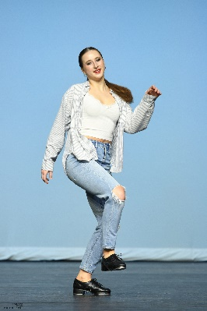
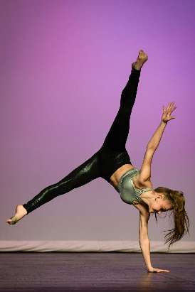


Print form, fill out table as needed, return to Dance Dimensions or scan and email to dancedimensions@sasktel.net

Dancer | Name
Age | Age
Level | Level
Guardian | Name
Address | Address
Phone | Phone
Email | Email
Dance Studio | Studio
Cost: $210.00 (ALL Day) Until May 31st Late Reg: $250.00
Fees can be paid VIA credit card or Debit/Cash when office is open (see website calendar for office hours)
☐ Charge credit card on file
OR
Credit Card Information
Name on Card | ☐Visa ☐Master Card
Card Number | Exp. Date

REGISTER NOW!

